samlogo_blue_pc.tif

**New Perspectives** Excel 2013

Tutorial 1: SAM Project 1a

Spring Software

CREATE AN EXPENSE REPORT

Project Goal

M Project Name

Project Goal

# PROJECT DESCRIPTION

Brendan Stevenson is an administrative assistant with Spring Software, a software development company in Cambridge, Massachusetts. He has been asked to track monthly expenses for each of the company’s salespeople, so he has begun work on a workbook summarizing monthly expenses for the sales team. His workbook contains two worksheets: Expenses Detail, which lists and categorizes all expenses, and Expenses by Salesperson, which summarizes the expense information. Brendan would like your help adding information to the workbook.

# GETTING STARTED

* Download the following file from the SAM website:
  + **NP\_Excel2013\_T1\_P1a\_*FirstLastName*\_1.xlsx**
* Open the file you just downloaded and save it with the name:
  + **NP\_Excel2013\_T1\_P1a\_*FirstLastName*\_2.xlsx**
  + *Hint:* If you do not see the **.xlsx** file extension in the Save file dialog box, do not type it. Excel will add the file extension for you automatically.
* With the file **NP\_Excel2013\_T1\_P1a\_*FirstLastName*\_2.xlsx** still open, ensure that your first and last name is displayed in cell B6 of the Documentation sheet. If cell B6 does not display your name, delete the file and download a new copy from the SAM website.

# PROJECT STEPS

1. On the *Expenses Detail* worksheet, cut the contents of the range **B1:B3** and paste them into the range **A1:A3**.
2. Add outside borders to the range **A5:D5**.
3. Change the width of column C to **16.00**.
4. Select cell B6 and then edit the cell content to be **125.24**.
5. Enter the values shown in Table 1 below into the corresponding cells in the range **B20:B25**.

# Table 1: Range B20:B25

© 2014 Cengage Learning.

|  |  |
| --- | --- |
| Cell | Value |
| B20 | 53.02 |
| B21 | 545.64 |
| B22 | 198.05 |
| B23 | 68.24 |
| B24 | 55.04 |
| B25 | 779.08 |

1. Select cell A26 and then enter the word **Total**. Add cell borders to the range **A26:B26** using the **All Borders** border format.
2. In cell B26, use the **SUM** function to create totals for the data in the range **B6:B25**.
3. In cell D6, type **TCM**, in cell D7, type **KTT**, and then use Flash Fill to automatically enter codes in the range **D8:D25**.
4. Zoom out to 90% on the *Expenses Detail* worksheet.
5. On the *Expenses by Salesperson* worksheet, change the orientation to landscape. (*Note*: Do not change the orientation of the Expenses Detail worksheet.)
6. In cell A2, edit the cell content to read **Sales Team Expenses by Salesperson**.
7. In the *Expenses by Salesperson* worksheet, change the height of row 3 to **15.00**.
8. In cell A5, edit the cell content to read **Salesperson**.
9. Change the width of column D to **19.00**.
10. Enter the values shown in Table 2 below into the corresponding cells in the range **A6:A10**.

# Table 2: Range A6:A10

© 2014 Cengage Learning.

|  |  |
| --- | --- |
| Cell | Value |
| A6 | Ken |
| A7 | Mona |
| A8 | Raj |
| A9 | Tori |
| A10 | Phillipe |

1. In cell D6, enter a formula to determine the Non-Travel expenses, where the Non-Travel Expenses equals the Total Expenses (cell B6) minus the Travel Expenses (cell C6).
2. Copy the formula you created in cell D6 to the range **D7:D10**.
3. In cell A12, delete the text **As of April 30, 2016**.
4. Apply the wrap text formatting to cell A13.
5. Zoom in to 110% on the *Expenses by Salesperson* worksheet. (*Note*: Leave the zoom at 90% for the *Expenses Detail* worksheet.)
6. Move the *Expenses Detail* worksheet to the left of the *Expenses by Salesperson* worksheet. (*Tip*: The *Expenses Detail* worksheet should be between the *Documentation* and the *Expenses by Salesperson* worksheets.)
7. Insert a new worksheet in the workbook, rename the worksheet **Expenses by Category**,and move the new worksheet to the end of the workbook.

Your workbook should look like the Final Figures on the following pages. Save your changes, close the workbook, and exit Excel. Follow the directions on the SAM website to submit your completed project.

# Final Figure 1 Expenses Detail worksheet

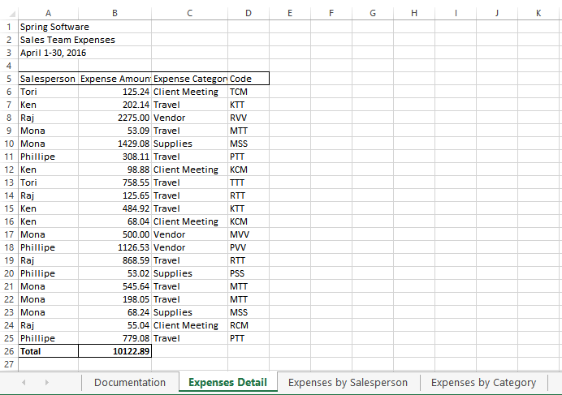

Microsoft product screenshots used with permission from Microsoft Corporation.

Copyright © 2014 Cengage Learning. All Rights Reserved.

# Final Figure 2 Expenses by Salesperson worksheet

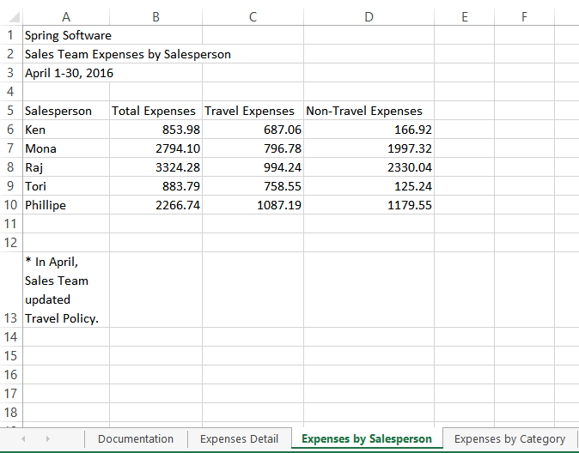

Microsoft product screenshots used with permission from Microsoft Corporation.

Copyright © 2014 Cengage Learning©. All Rights Reserved.